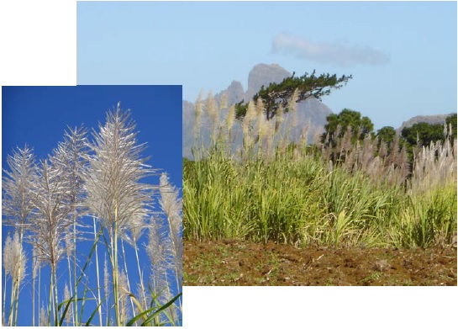
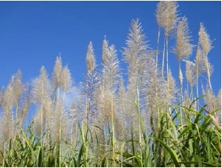
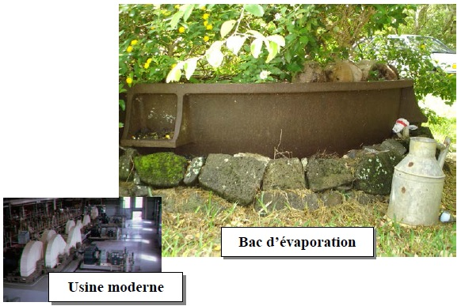
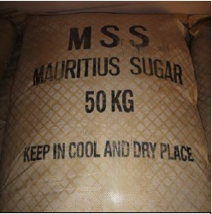
Sugar cane (Saccharum officinarum), a variety of grass, is cultivated in all tropical or warm temperate climates. Sugar and its derivatives are extracted from its stem, which measure between 2.5 to 6 metres in height, and 1.5 to 6 centimetres in diameter. In average, the sucrose level in the sugar cane is between 12 and 15%. Economically speaking, it is one of the most important plants in the world, even now when its production is on the decline. It is said to have been spread by man first in all the Pacific islands, and in the Indian Ocean all the way to Malaysia. Until the beginning of the 19th Century, sugar cane was the only important source of sugar; today, it still represents 65 to 70% of total production (in Europe, sugar production derives essentially from sugar beets).

Cane cuttings are planted either in furrows, flat in the ground or in raised beds, depending on the soil’s humidity. Sugar cane plantations need a fair amount of irrigation while not faring well in excessively humid soils; porous soils are thus ideal to grow sugar cane. Plants produce about ten reeds (stems) yearly and cuttings are replaced roughly every five years. The crop is harvested after 10 to 12 months, or a few months later, depending on climatic conditions and agricultural practices.

The author of La Quarantaine notes realistically that “Médine was the first to cut the cane because we were in the West[ern part of the island] and that the cane matured faster [there]” (Q, 90), describing the rituals that accompany “the beginning of harvest” (ibid.). During the dry season, sugar cane reaches maturity, and the leaves dry out. Sugar concentration is then highest in the stem’s lower section. The cane is usually harvested at the beginning of the flowering cycle, when there is a dip in sugar levels. Leaves are often stripped from the plant before harvest to facilitate the cutters’ work, a task assigned to women in Le Chercheur d’or (CO, 309). Sometimes the field is set on fire to rid plants of their leaves, although this practice is rarely used today as it leads to a drop in sugar content. Cutters sever the reed right above the first node, cut off the growing tip, and section it if too long, using “sabers” or “long knives” (Q, 90), notes J.-M.G. Le Clézio, whose Mauritian texts resound of the cane cutters’ shouts, as echoed by the children “Aouha! Aouha!” (CO, 16 ; Q, 90). The growing tips are left to fertilize the fields. The cane reeds are then loaded into lorries – or ox-carts at the time of the Chercheur d’or – which deliver them to the sugar factory, located in short proximity to the plantations since sugar content declines rapidly once the cane is cut, losing 2.4 measures in less than 10 days. More and more, the harvest is mechanized, machines cutting reeds and removing leaves, while small bulldozers armed with power tongs load the cane onto waiting lorries. Of note the fact that the sugar industry has now been highly centralized in many countries, especially in the Mascarene islands. In Mauritius, only 4 sugar factories remain, each much more powerful than those of the Chercheur d’or, and located at the four corners of the island.

According to the traditional method named after the Dominican friar Jean-Baptiste Labat (1663-1738) who described it, sugar is purified by means of a “team or crew” of six boilers. The cane juice is first collected in the “Big One” (La Grande), clarified in the “Clean One” (La Propre), boiled down a first time in the “Torch” (Le Flambeau), then in the “Syrup”; the juice finishes cooking in the “Battery”. Once cooked, the liquid sugar crystallizes in huge wooden vats, the “rafraichissoirs” (or coolers). The massecuite or cooled sugar is placed in containers drilled with holes to evacuate the syrup. After four weeks, sugar is ready for use. Molasses, from the Greek melan, meaning black, a very thick and viscous residue containing a slight amount of sugar, vitamin B6 and minerals such as calcium, magnesium, potassium and iron, is then collected and can be fermented and distilled to make industrial rum; agricultural rum, on the other hand, comes from fermenting cane juice. Nowadays, this process is completely automated. The cane reeds are crushed in a grinder to extract the cane juice, also called vesou. The fibrous residue or bagasse, in other words the plant’s cellulose, is used to heat the ovens where the juice is thickened and evaporated to obtain the syrup, which is then clarified and concentrated to extract crystallized raw sugar, called cassonade. This brown sugar will then be refined into white sugar in a refinery. The author of the Chercheur d’or lyrically refers to the syrup stage of the process: “the clear juice which trickles on the cylinders, flows toward the boiling vats […]” and to the children’s joy when they scoop and suck on the first lumps of sugar, “the burning hot paste covered with blades of grass and strands of bagasse” (CO, 21-22). On the practical side, electricity produced by sugar factories burning bagasse, are routed to the national grid.

It goes without saying that the plantation economy has a deep influence on the sociocultural development of the countries involved, especially as it pertains to the French islands of the Caribbean and the Indian Ocean where sugar cane cultivation is widespread in the 17th Century. The massive importation of slaves, from Western Africa to the Caribbean, and from Madagascar, Mozambique and Western Africa to the Mascarene islands, forms the basis for a society where the enslaved majority works incessantly for a small minority of Whites. No need to detail here the Black Code, marooning or the gradual transculturation of populations, nor the development of creole as a vehicular – and vernacular – language over the years. We must however mention, if only briefly, that the majority of slaves, classified by the synecdoche hoes (pioches) in archival documents, work in the fields. They are often (poorly) fed, housed and clothed in exchange for brutal work, in degrading conditions and under a cruel sun. Many of them escape and hide in the surrounding forests, or take refuge on the Morne mountain, today a UNESCO World Heritage site, where archaeological digs have unearthed maroon camps.

In his work De L’esprit des lois, Montesquieu ironically mentions the championing of slaves by sugar barons: “Sugar would be too expensive, were not the plant cultivated by slaves”. One of the protagonists of La Quarantaine echoes this irony, speaking of “a sugar baron as you would a slave trader” (Q, 429). In this novel, sugar cane exploitation is conjured up through the memories of Jacques, the only one having known the family property as a child (Q, 88-89). After the British conquest of the island, slavery is abolished in 1835. However, the British government imports Indian coolies who are contracted by plantation owners to work in the cane fields, in conditions closely reminiscent of those of Black slaves. Indenture, as it is called, is depicted in La Quarantaine by J.-M.G. Le Clézio, through Ananta and Giribala’s narration of escaping from the Sepoy Revolution in India to be hired on the Alma plantation (Q, 408-413). Women are dressed in a jute sack called gunny to work in the fields, under the eye of a field manager and sirdars, (usually Indian) foremen who coordinate task assignments. Workers who die on duty are sometimes buried in the fields, under cairns made of basaltic rocks piled in pyramids, after they have been removed from newly cleared space for cultivation. Arduous work, led by slaves or their offspring, and subsequently by coolies, are precisely described by Le Clézio in Le Chercheur d’or (308-310).

It is not surprising then, that maroons lent their support to Ratsitatane, a Malagasy prince exiled in Mauritius, during the 1822 uprising. Six of them are condemned to death by the British government; Ratsitatane, Latulipe and Kotolovo are beheaded. J-M.G. Le Clézio relates this historical event in Révolutions, through Kiambe’s story. She recites her African name in a litany to reclaim ownership. The Ratsitatane event is echoed in the spontaneous and extremely violent uprising as related by J.-M.G. Le Clézio in Le Chercheur d’or where a cruel field manager, having hit and insulted Black workers, is violently thrown in “the mouth of the bagasse oven” (CO, 67-68). Le Clézio also mentions hunger strikes (CO, 311). In 1943, a confrontation between the police and workers during a strike at the Belle-Vue Harel factory in the North of the island, results in four deaths, including Anjalay Coopen, a young woman who came to symbolize resistance to colonial authority and to the work conditions imposed by plantation owners.

Sugar sack ready for export.
(Sacks are no longer made of goni, Creole spelling of gunny or jute).

We have focused on Mauritius in the context of sugar cane exploitation because the island is J.-M.G. Le Clézio’s “tiny motherland”, the birthplace of his ancestors. François Alexis Le Clézio, émigrating from Britanny in France, establishes himself in the then Isle of France in 1793. In 1856, his son Eugène buys the villa Euréka together with a sugar cane plantation in the Moka region. For generations, the family is closely linked to sugar production in the island. Sir Henry Leclézio (Mauritian spelling of the surname) (1840-1929), “President of the Chamber of Agriculture, and last owner of the Alma family estate, fostered scientific development in the Mauritian sugar industry” (d’Unienville, 328-329). His grandson Fernand is the driving force behind the first centralization of factories in FUEL (Flacq United Estates Limited), long the biggest factory on the island. The financial ruin of Sir Eugène Le Clézio’s branch of the family, and the sale of Euréka to his brother Sir Henry, at the beginning of the 20th Century, causes the displacement of J.-M.G. Le Clézio’s ancestors, a diaspora romanticized in all the Mauritian Cycle novels of the 2008 Nobel Prize in Literature. A source of family wealth, sugar cane was then, and still is, one of the major economic resources of Mauritius.

Eileen Lohka

BIBLIOGRAPHY
CAUNA, Jacques, Au temps des isles à sucre ; Histoire d’une plantation à Saint-Domingue au XVIIe siècle, Paris, Karthala - A.C.C.T., 1987 ; D’UNIENVILLE, Noël, L’île Maurice et sa civilisation, Paris, G. Durassié & Cie Éditeurs, 1949 ; FAUQUE, Claude, L’Aventure du sucre, une histoire de l’île Maurice, publication of the L’Aventure du sucre Museum, Beau-Plan, Île Maurice, 2002 ; LE CLÉZIO, J.-M.G., Le Chercheur d’or, Paris, Gallimard, 1985 ; La Quarantaine, Paris, Gallimard, 1995 ; http://fr.wikipedia.org/wiki/Canne_à_sucre (consulted on October 22, 2013).

Photos : © Eileen Lohka

